Water Pollution Monitoring RC Boat

The quality of drinking water plays a crucial role in the health of animals and human beings. Lakes and reservoirs, canals one of the major sources of drinking water. Water quality monitoring of these water bodies requires a lot of effort as operators need to get in a boat with all sensors and manually check the entire lake.
So we here design a solution for easy water quality checking of vast water bodies with ease.. This RC boat will help to measure the ph level and turbidity level. This will further help us to maintain the water clean. This project is remote-operated and controlled by an RC remote using which it can be maneuvered accordingly, a motorized propeller system to provide the forward propulsion and servo motor arrangement to provide with the steering using a rudder.
As per the commands received by the rc receiver the controller operates the DC motor which rotates the propeller through a flexible bearing and shaft. Now we have an a rudder attached to a servo motor used to steer the boat as per controller instructions.
Additionally, we have two sensors to determine water quality, we include PH sensors as well as turbidity sensor. These sensors will detect the presence of suspended particles in the water. We also have a GPS module and micro SD card, which will log the data from sensors as well as GPS locations at particular intervals.
Thus the water quality monitoring rc boat can be used for water quality monitoring on lakes and reservoirs with ease.

Components:
- Raspberry Pi
- Ph sensor
- Propeller
- Shaft
- Rudder
- Turbidity sensor
- GPS module
- SD card module
- RC receiver
- RC remote
- Servo Motor
- Lights
- Resistors
- Capacitors
- Cables and Connectors
- Diodes
- PCB and Breadboards
- LED
- Mounts and Joints
- Switches & Buttons
- Screws and Bolts

Advantages:

- Lake Pollution Monitoring
- Reservoir Pollution Monitoring
- Easy to Operate
- Low Power Consumption
- Automatic Data Logging
- Long Range

Disadvantages:

- Limited Range
- Limited Operating Time as per Battery Capacity

Block Diagram:

Front View
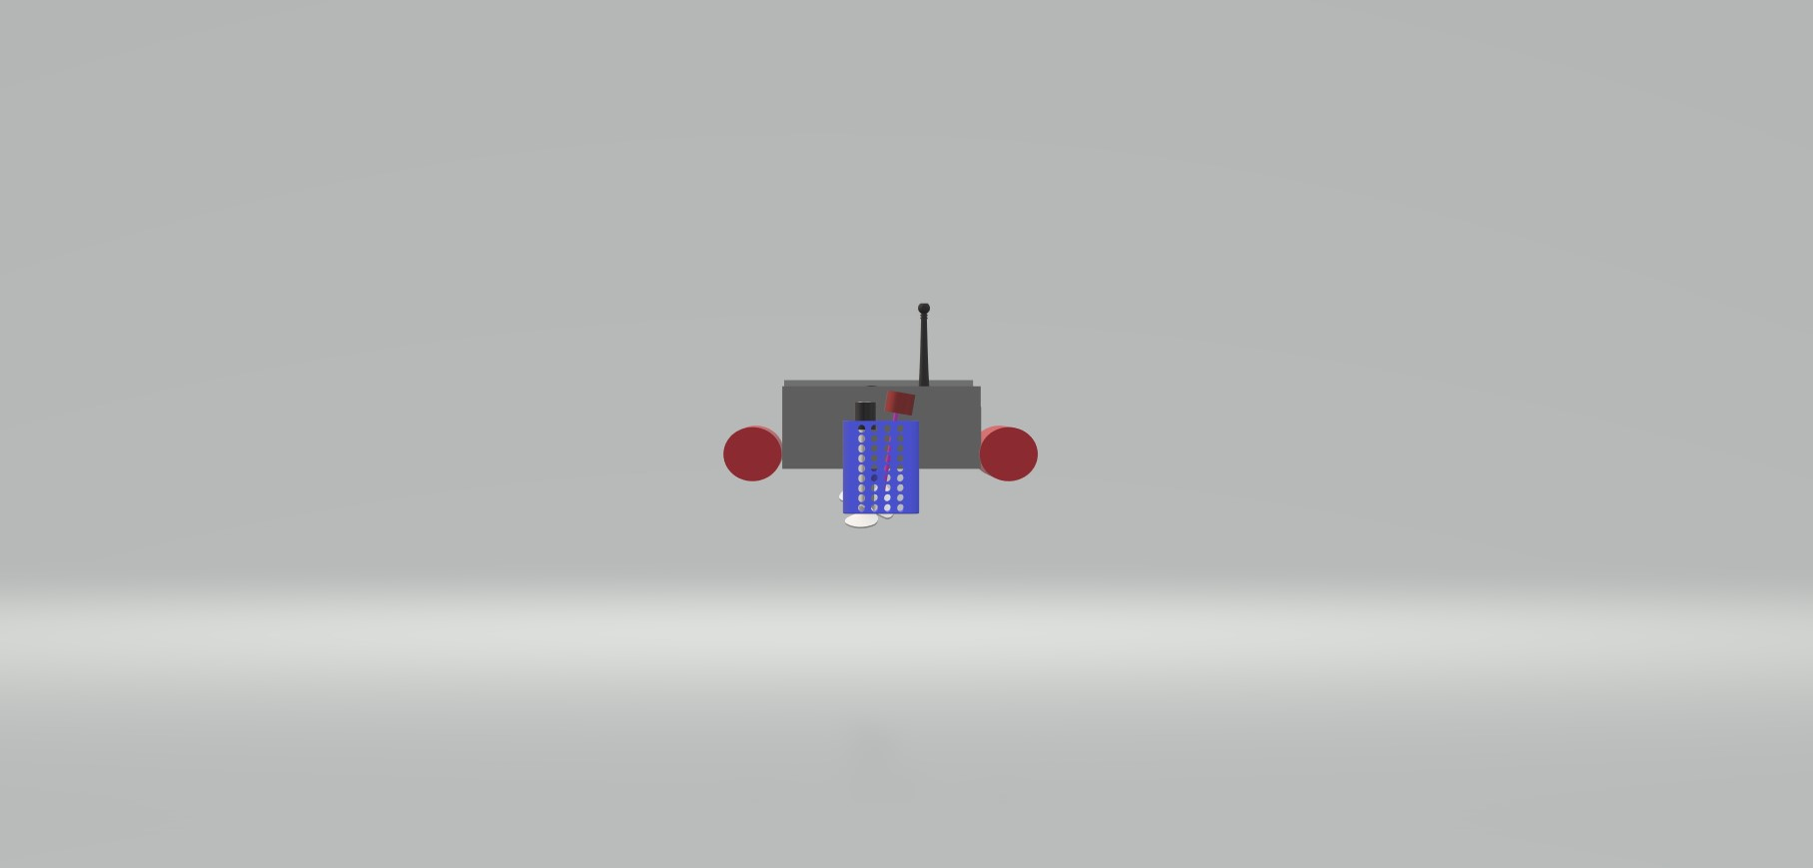

Side View
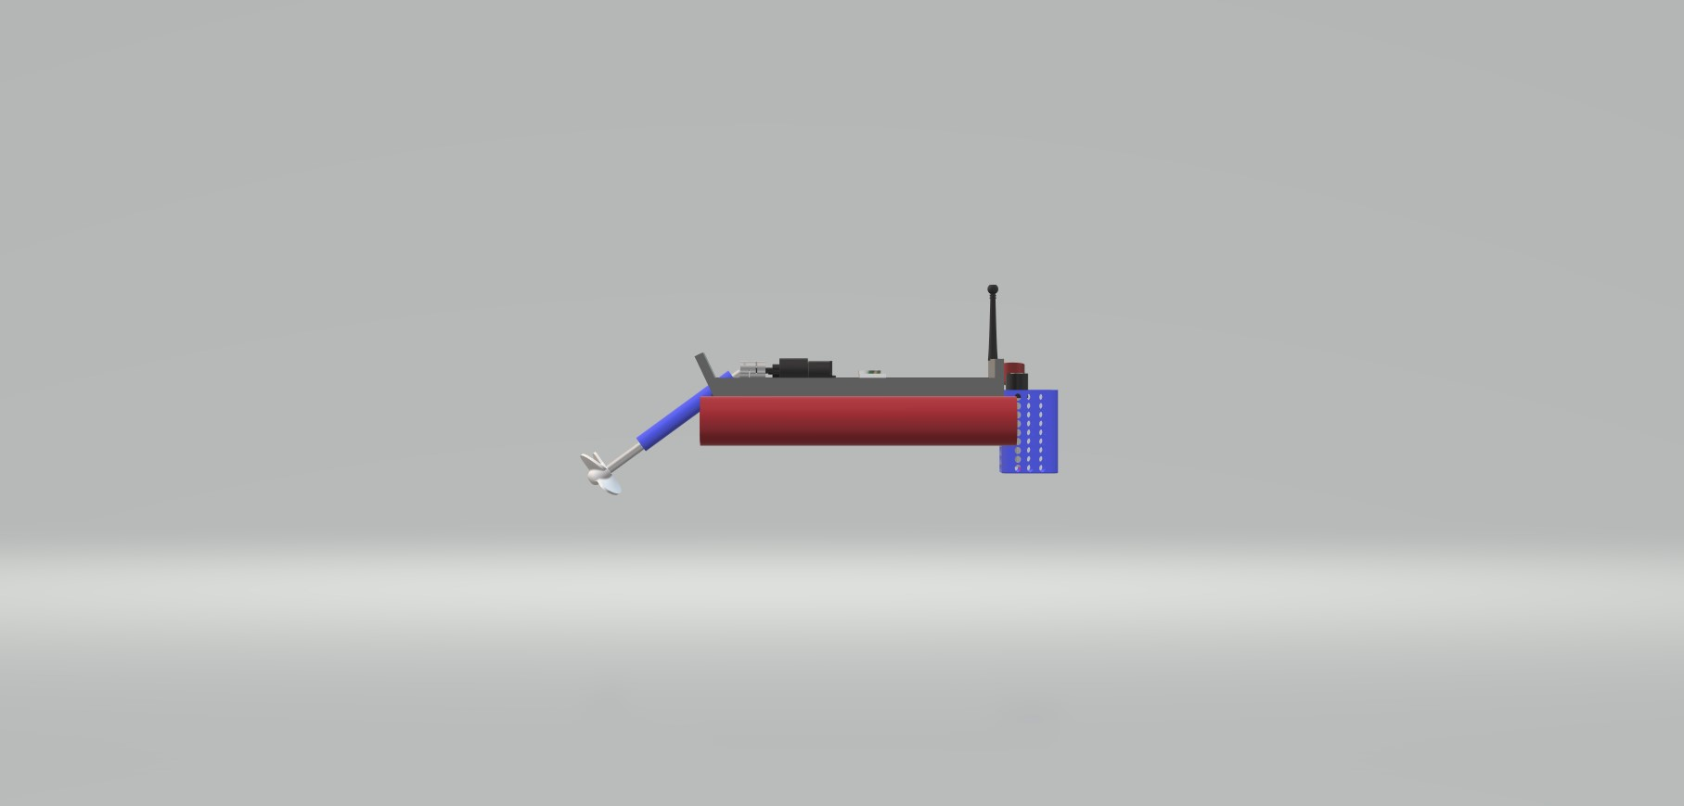

3D Views
